**20TH Scientific Committee Meeting**

**15 October 2018, Chengdu, China**

**AGENDA**

|  |  |  |
| --- | --- | --- |
| **TIME** | **TOPIC** | **LEAD / SPEAKER** |
| 09.00 – 09.10 | 1. **Welcome**     1. From SC Chair    2. From IRDR Executive Director    3. From the Host Institution    4. Round Table Introductions | Shuaib Lwasa  Han Qunli  Cui Peng  SC members and observers |
| 09.10 – 09.15 | 1. **Approval of the Agenda**    1. SC-20 Agenda | Shuaib Lwasa |
| 09.15 – 10.00 | 1. **Co-sponsor/host Update**    1. UNISDR (10 minutes)    2. Global Platform Preparation (15 minutes)    3. CAS/RADI (10 minutes)    4. STAG Update (10 minutes) | Shoko Arakaki  Shuaib Lwasa  Liu Jie  Rajib Shaw |
| **10.00 – 10.20** | **Coffee Break + Group Photo** |  |
| 10.20 – 10.40  10.40 – 11:40 | 1. **IPO Update**     1. IPO Report on the Implementation of Action Plan    2. Discussion 2. **IRDR Working Group Development**   **(10 minutes for each – with Q&A)**   * 1. DATA   2. RIA   3. AIRDR   4. FORIN   5. CCA-DRR Synergy   6. SFDRR Synthesis Report | Han Qunli  Shuaib Lwasa  Virginia Murray/Bapon Fakhruddin  Bapon Fakhruddin  Virginia Jimenez  Irasema Alcántara-Ayala  Riyanti Djalante  Haruo Hayashi |
| **11.40 – 12.40** | **Lunch** |  |
| 12.40 – 14.10 | 1. **IRDR pre-discussion on main themes of the International Conference on Integrated Science and Technology Contributions and Role and deliverables of ICoEs and NCs**    1. Discussion on 2016 S/T Road Map and the implementation strategy    2. Discussion on Sendai anticipated new hazards    3. Discussion on Synthesis system of science and technology    4. Role of ICoE/ NC on specific deliverables in GP 2019 and beyond | Rajib Shaw / Han Qunli |
| **14.10 – 14.30** | **Tea / Coffee Break** |  |
| 14.30 – 17:00 | 1. **The Future of IRDR**    1. New contexts of SFDRR    2. Consolidation of IRDR achievements: knowledge capacity, networks, strategic institutional partnership    3. Revisiting Original IRDR Science Plan 2. SC 21TH meeting – location and timing 3. Wrap up | Han Qunli / Shuaib Lwasa  Han Qunli / Shuaib Lwasa  Shuaib Lwasa |
| **17.00** | **Opening Night Reception. Dinner-Free Arrangements** |  |

**International Conference on**

**Integrated Science & Technology Contributions for Informed National Policy-Making and Action for the Implementation of the Sendai Framework**

**16-17 October 2018, Chengdu, China**

**Concept Note**

To reconcile the relationships among disasters and development, important global decisions were made and came to fruition in 2015, with the Sendai Framework for Disaster Risk Reduction, the Sustainable Development Goals and the Paris Agreement on Climate Change. In the recognition that the science and technology in society should be at the frontier to strengthen disaster resilience for sustainable development, coordinated efforts among international science communities, including IRDR and its International Centers of Excellence (ICoEs) and National Committees (NCs), Future Earth, WCRP and Urban Health and Well Being, as well as global observation and data system programs and STAG of UN ISDR should be made to promote and support scientists and practitioners in countries and regions to work closely together with all relevant stakeholders based on the respective local context.

Science Technology Road Map for implementation of Sendai Framework was developed and agreed in Geneva in January 2016. The Global Resilience Forum, held in Tokyo, November 2017, agreed to: 1) formulate guidelines for supporting national platforms for DRR by making the best use of science and technology, and 2) produce a synthesis system on science and technology for disaster risk reduction. Through these, there needs to create an enabling environment for a better science-based decision making at national and regional level.

By integrating all the efforts being made by the wide range of science and technology communities, while anticipating the needs for concreate contributions from science & technology community toward GP 2019, this conference aims:

1. To undertake a review of the Science Technology Road Map of 2016, and contextualize it to align with the new global processes, and develop an implementation strategy
2. To discuss and agree on the definition and identify gaps in the new hazards described in the Sendai Framework
3. To discuss the format, process and responsibilities of the synthesis system on science and technology for disaster risk reduction and guidelines for national platforms
4. To strengthen the science technology partnership for its effective contribution to the Global Platform (GP), and develop plan for Science Technology conference as pre-event of GP.

**Venue:** Institute of Mountain Hazards and Environment, Chengdu China

**Co-Hosts:**

Integrated Research on Disaster Risk (IRDR)

International Science Council (ISC)

United Nations International Strategy for Disaster Reduction (UNISDR) Science Technology Advisory Group (STAG)

Science Council of Japan (SCJ)

Institute of Mountain Hazards and Environment

**Expected Participants:** (around 50)

IRDR SC Members (15); IRDR ICoE / NC Leaders (10); IRDR and IMHE (5); STAG and Regional STAG representatives (5); Partners and key members of the Global Resilience Forum/ S/T partnership (15)

**16 October 2018, Chengdu, China**

**AGENDA**

|  |  |  |
| --- | --- | --- |
| **TIME** | **TOPIC** | **LEAD / SPEAKER** |
| 09.00 – 10.00 | 1. **Plenary 1**    1. Opening and Welcome (15 minutes): IRDR SC Chair, ISDR / STAG and CAST (5 minutes each)    2. Reports from the Key global and regional initiatives (45 minutes: 15 X 3)  * STAG (global and regional) * IRDR (Action plan: 2018-2020) * SCJ (Tokyo Resilience Forum) | Chair: Shuaib Lwasa |
| **10.00 – 10.30** | **Coffee Break + Group Photo** | |
| 10:30 – 12:00 | 1. **Plenary 2**   Inputs from national and regional initiatives  2.1. IRDR NC China  2.2. IRDR NC Japan  2.3. IRDR ICoE CR  2.4. IRDR ICoE NEST  2.5. IRDR ICoE TDDR  2.6. IRDR ICoE RCS  2.7. IRDR ICoE Taipei  2.8. IRDR ICoE CCOUC  2.9. IRDR ICoE DCE  2.10. Flagship Project: SIDRR, IMHE | Chair: Han Qunli |
| **12.00 – 13.00** | **Lunch Time** | |
| 13:00 – 14:00 | 1. **Plenary 3**   Short overview of four breakout sessions (20 minutes each):    **3.1. Review and contextualization of S/T road map and implementation strategy**  *Annisa Triyanti and Hirokazu Tatano*  **3.2. Sendai new hazards**  *Irina Rafliana*  **3.3. Synthesis system of science and technology contributing to national platform**  *Haruo Hayashi* | Chair: Han Qunli |
| 14:00 – 17:00 | 1. **Breakout Discussion 1**   **4.1. Review and contextualization of S/T road map**  **and implementation strategy**  *Chair: Annisa Triyanti and Hirokazu Tatano*      **4.2. Sendai new hazards**  *Chair: Irina Rafliana and Helene Descombe*    **4.3. Synthesis system of science and technology contributing to national platform**  *Chair: Haruo Hayashi and Ian Clarke* | **4.1 Members:** Qunli Han, Chen Fang, Sameer Deshkar, Riyanti Djalante, Gloria Chan, John Handmer, Rajib Shaw +XXX  **4.2 Members:** Shuaib Luwasa, Jörn BIRKMANN, Jian-Cheng, Michael Boyland, Cui Peng, Atta-ur Rahman,+ XXXX  **4.3 Members:** Toshio Koike, David Johnston, Helene Descombe, Victor Lemus Garcia, Amod Dixit, Tetsuya Ikeda, Wei-sen Li + XXXX |
| **18:00** | **Reception** | |

**17 October 2018, Chengdu, China**

**AGENDA**

|  |  |  |
| --- | --- | --- |
| **TIME** | **TOPIC** | **LEAD / SPEAKER** |
| 09:00 – 09:30 | 1. **Plenary 5**   Recap of Day 1 (15 minutes) | Han Qunli |
| 09:30 – 12:00 | 1. **Breakout Discussion 2 (Chair same as Day 1)**    1. Review and contextualization of S/T road map and implementation strategy    2. Sendai new hazards    3. Synthesis system of science and technology contributing to national platform |  |
| 11:30 – 12:00 | 1. **Visiting the Landslide Simulation Lab of IMHE** |  |
| **12:00 – 13:00** | **Lunch Time** | |
| 13:00 – 15:00 | 1. **Plenary 5**   Plenary presentations from each group  (30 minutes per group: 15 minutes presentation + 15 minutes Q/A | Chair: Shuaib Lwasa |
| **15:00 – 15:30** | **Coffee Break** | |
| 15:30 – 17:30 | 1. **Plenary 6**   **Way forward and next step**  Panel discussion on summarizing the key action items, and preparation for GP 2019 and the Science Technology Conference of 2019 as pre-event of GP | Chair: Rajib Shaw |
| **17:30 – 17:45** | **Closing remarks** | |
|  |  | |

**18 October 2018, Chengdu, China**

**AGENDA**

|  |  |
| --- | --- |
|  | **Field visit to DRR sites near Chengdu** |

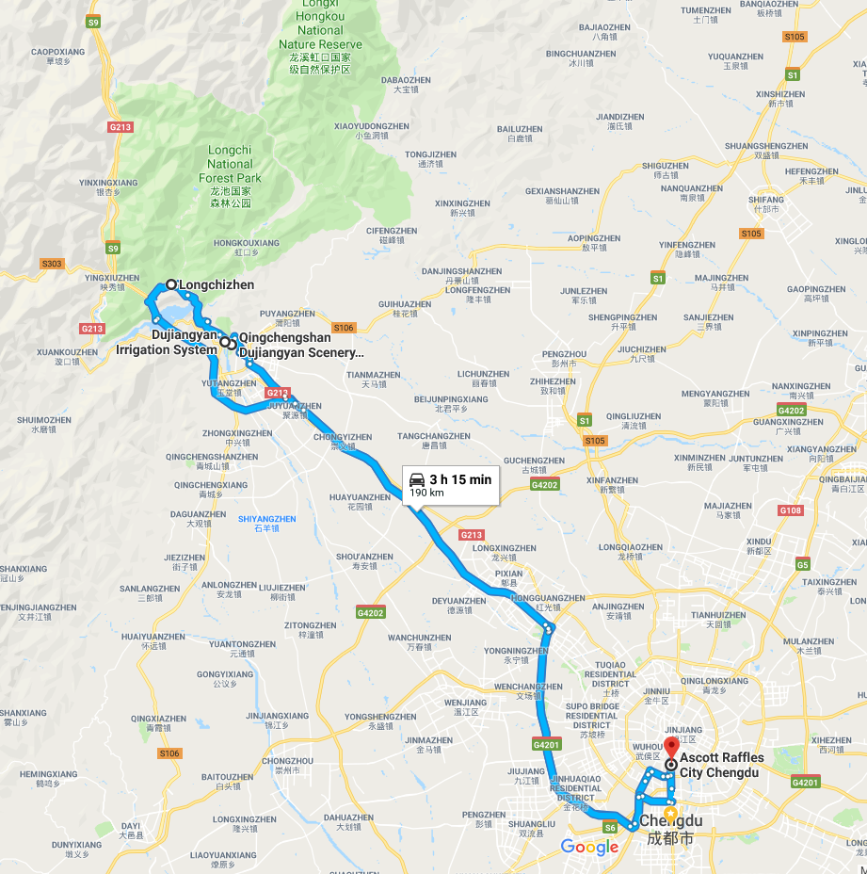

# Longchi (landslides and debris-flows)

Longchi is a town located in the mountain area. The villagers built small hotels for the tourists along the valley. However, the buildings were destroyed by the landslides and debris-flows triggered by heavy rainfalls.

In this site, we will see the buildings filled with rocks and muds and learn the monitoring and early warning systems set by IMHE.

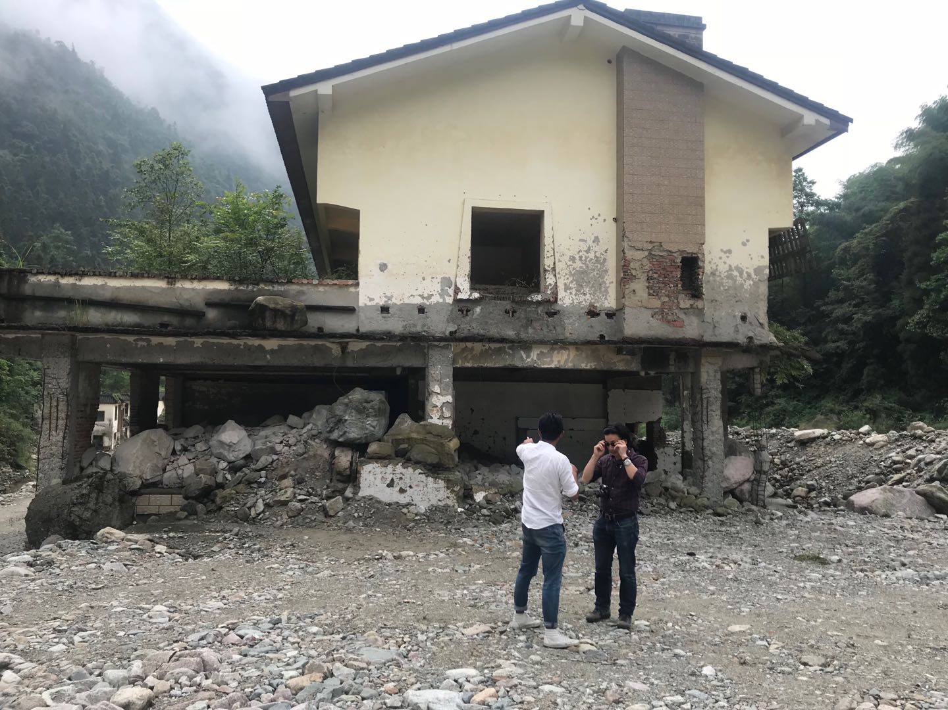

# Dujiangyan Irrigation System (earthquake)

The Dujiangyan is an ancient irrigation originally constructed around 256 BC as an irrigation and flood control project, it is still in use today. It is a UNESCO World Heritage site. Initial reports indicated that the Yuzui Levee was cracked and the cultural monuments were damaged in the 2008 Wenchuan Earthquake. We will learn the recovery and the “build back better” after the earthquake.

# Qingchengshan (landslides and debris-flows)

The Wulipo landslide, triggered by heavy rainfall on July 10, 2013, transformed into debris flow, resulted in the destruction of 12 houses, 44 deaths, and 117 missing. The systematic investigation conducted by a team from IMHE has led to a new understanding about the formation and evolution process of this hazard.

Chen, Xing-zhang, and Yi-fei Cui. "The formation of the Wulipo landslide and the resulting debris flow in Dujiangyan City, China." *Journal of Mountain Science* 14.6 (2017): 1100-1112.