21 September 2018

***PRACTICAL ARRANGEMENTS***

**The 20th Meeting of the IRDR Scientific Committee**

**Chengdu, China**

**15 October 2018**

**International Conference on**

**Integrated Science & Technology Contributions for Informed National Policy-Making and Action for the Implementation of the Sendai Framework**

**16-17 October 2018**

**Field Trip**

**18 October 2018**

**1. VENUE**

**Institute of Mountain Hazards and Environment (IMHE), Chinese Academy of Sciences**

#.9, Block 4 , Renminnanlu Road, Chengdu,China

WIFI will be available at the meeting room.

**2. Hotel (For those who stays at the IRDR contract Hotel)**

**Ascott Raffles City Chengdu**

No. 3, Section 4, South Remin Road Wuhou District, Chengdu 610041 China

Tel: +86 28 6268 2888

<https://www.the-ascott.com>

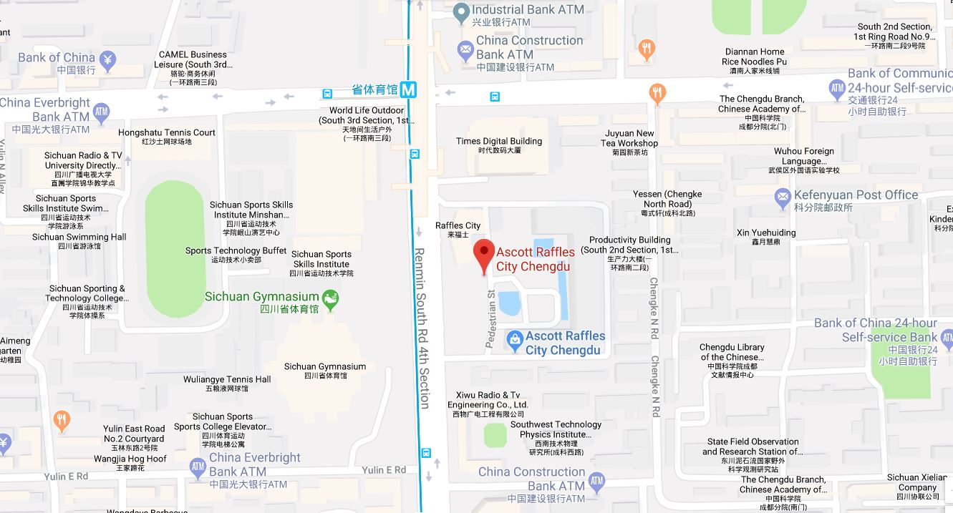

Useful information about the hotel:

- Check in time: 14:00 (early check in will be possible if the room is available)

- Check out time: 12:00

- 500 CNY/room.night or equivalent foreign currency (USD/EURO/GBP/JPY) deposit will be taken when check in. Credit card preauthorization is recommended.

- The Hotel offers complimentary breakfast, and WIFI as parts of the accommodation package.

- Concierge in Hotel lobby speaks good English and may help to call taxi upon request.

- The hotel is walking distance to the meeting venue.

**3. Meals**

- Boxed lunches (Regular meals and vegetarian diet) will be provided at the meeting room.

- Reception on 15th and 16th April will be arranged at the local restaurant (walking distance).

1. **Local transportation**

* Airport transportation

Please follow the sign at the Airport to the Taxi Waiting Area. Here is the note to the taxi driver: **(For those who stays at Ascott Raffles City Chengdu)**

**请送我去：成都雅诗阁来福士**

**地址：成都市武侯区人民南路四段三号来福士广场T3雅诗阁**

**电话：028 62682888**

From the Airport to the hotel, the distance is 17km or so. It normally takes 30-40 minutes by taxi, and cost roughly 50 CNY.

**5. ELECTRICITY**

- The electricity in China is generally 220V, 50HZ, AC. Please be wary about plugging in your electronic equipment which may be designed to handle a lower or higher voltage.

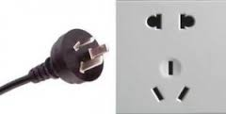

**6. Currency**

The currency in China is the Chinese Renminbi (CNY)

- Automatic Teller Machines (ATMs) are very common throughout towns in Beijing as well as the airport.

- MasterCard and Visa are accepted easily at all ATMS, and most of shops and restaurants. Please be aware that some local shops and restaurants may only accept cash, however the electronic payment is very common, like Alipay and Wechat.

- Foreign currency exchanges: can be made at Chengdu Shuangliu International Airport or any banks in town with your passport.

**7. PHONE**

Most overseas Sim cards work in China however must apply international roaming function before your departure.

**8. WeaTHER**

It is early autumn weather of Chengdu in October. Whilst the average high temperature is 21°C (70°F), the average low is 15°C (59°F). October proves to be the best month to visit Chengdu due to its comfortable weather for outdoor activities. However, visitors are reminded that the variation of temperature during the day and night could be quite substantial, especially in the mountainous area.  The variation there could be like 20°C (68°F) during the day and 5°C (41°F) at night.

**9. EMERGENCY CONTACT NUMBERS**

If you need to get in contact with someone concerning matters related to the meeting logistics, please use the numbers below:

LANG Lang Mobile: +86 1760 1600 998

HAN Qunli Mobile: +86 1360 1115 414