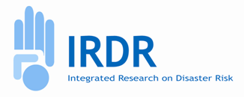
IRDR SC Meeting
12:30-14:00 (UTC), 13 April, 2026
Online

Agenda
Meeting link: IRDR SC Online Meeting | Meeting-Join | Microsoft Teams (ID:440 351 529 269 52, Password: WD784TP9)

Documents:
- [Doc 1] IRDR Scientific Projects
- [Doc 2] IRDR Fellow

Item 1: IRDR Scientific Projects – presentation by ED and discussion (40 min) [Doc 1]
Item 2: IRDR Fellow – presentation by ED and discussion (30 min) [Doc 2]
Item 3: Updates from IRDR YSP (10 min)
- News about IRDR Young Scientists Forum and ISC ECR Travel Fund
- IRDR YSP self-governance
Item 4: Update on ICoEs and NCs (5 min)
- Signing of MoU and 2026 Call for EoI
- Re-Engagement Exercise of NCs
Item 5: AOB (5 min)

